# 1.1-what is testing

start at 5:01

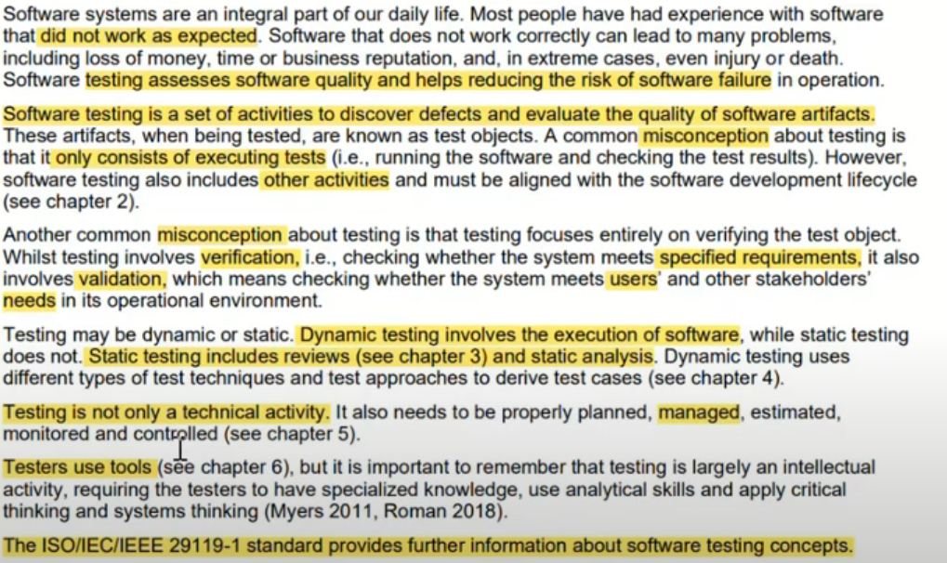

## 1.1.1-Test Objectives

start at 13:30

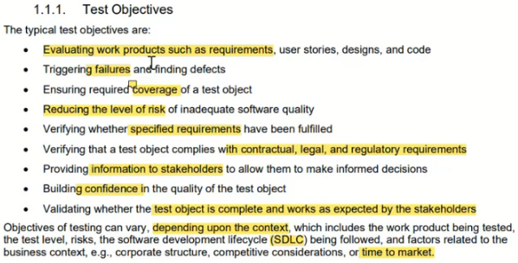

## 1.1.2-Testing and Debugging

start at 25:09

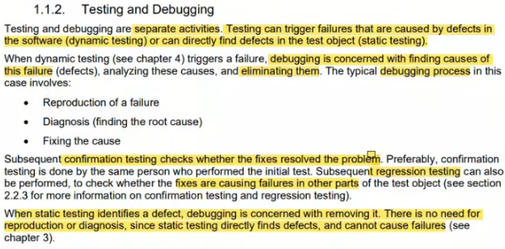

# 1.2-Why is testing Necessary

start at 29:57

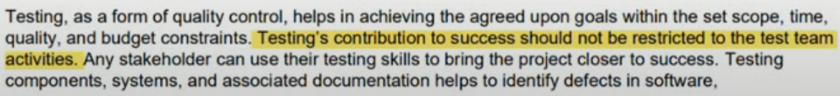

## 1.2.1-Testing’s Contributions to Success

start at 30:37

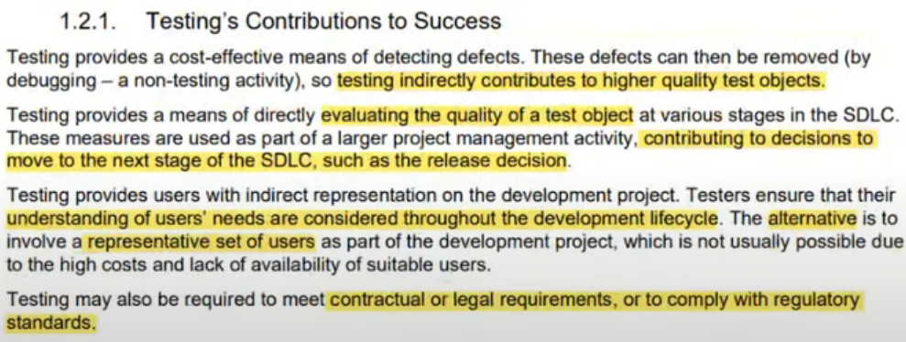

## 1.2.2-Testing and Quality Assurance (QA)

start at 33:22

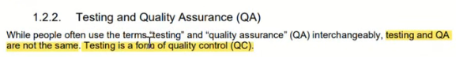

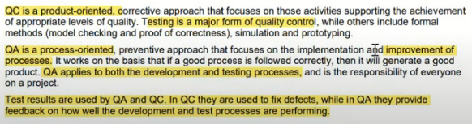

## 1.2.3-Errors, Defects, Failures and Root Causes

start at 37:44

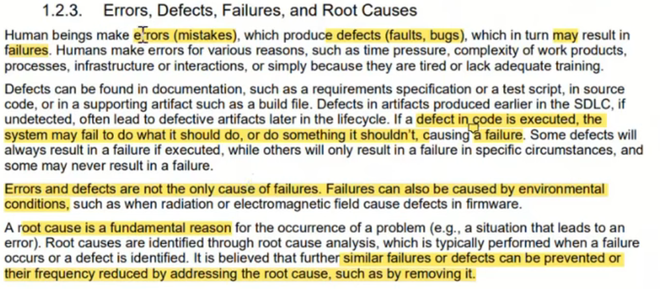

# 1.3-Testing Principles

start at 42:32

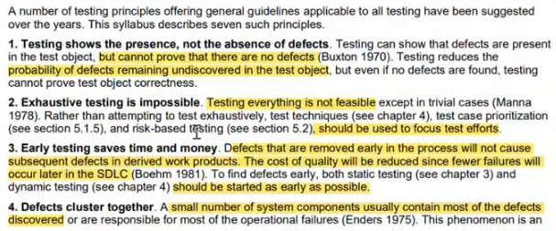

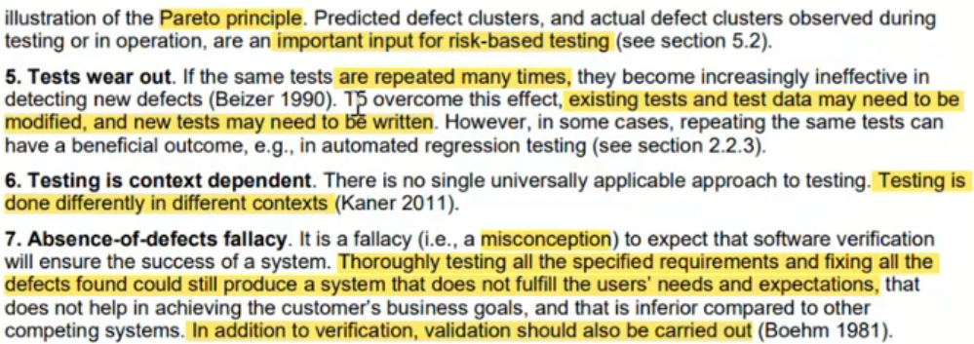

# 1.4-Test Activities, Testware and Test Roles

start at 52:02

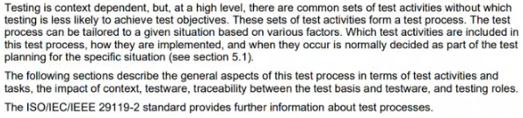

## 1.4.1-Test Activates and Tasks

start at 52:02

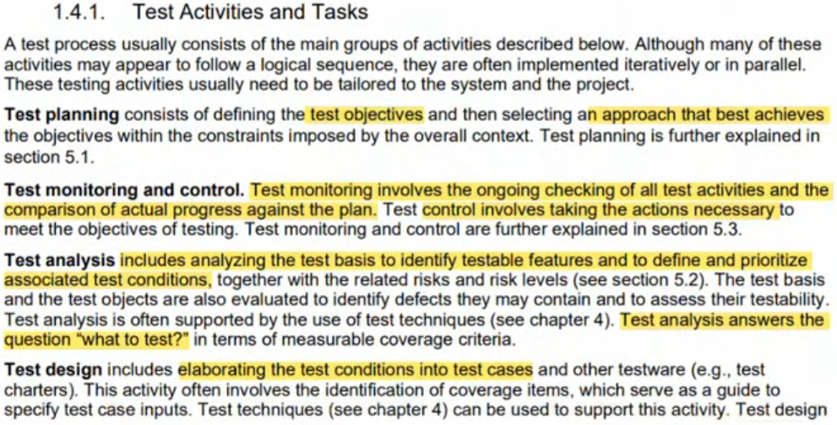

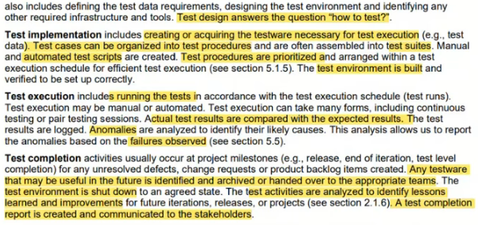

## 1.4.2-Test Process in Context

start at 1:06:00

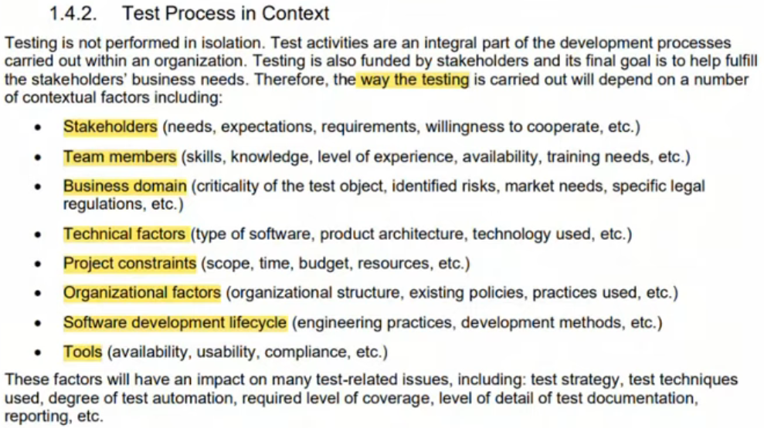

## 1.4.3-Testware

start at 1:10:04

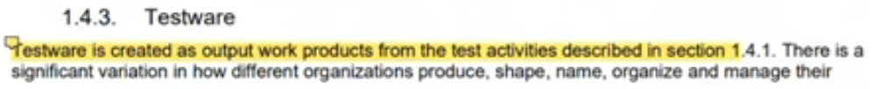

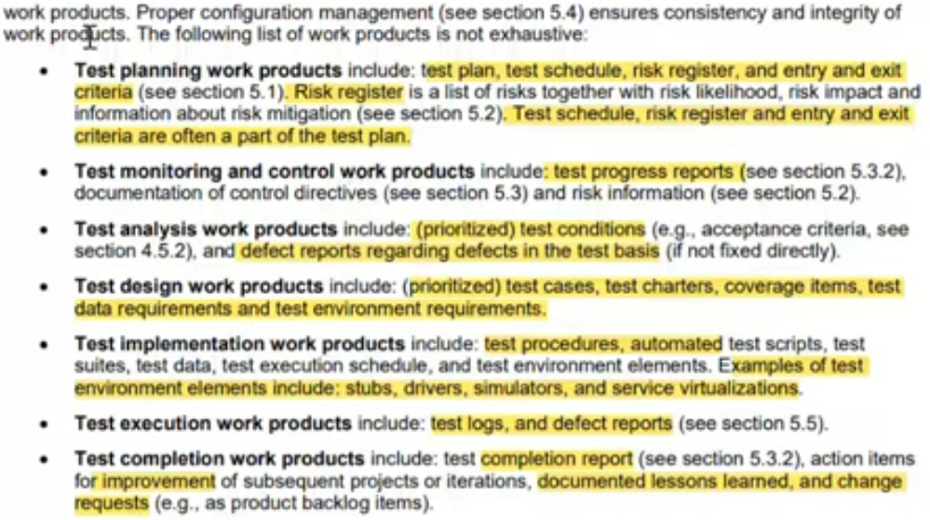

## 1.4.4-Traceability between the Test Basis and Testware

start at 1:20:35

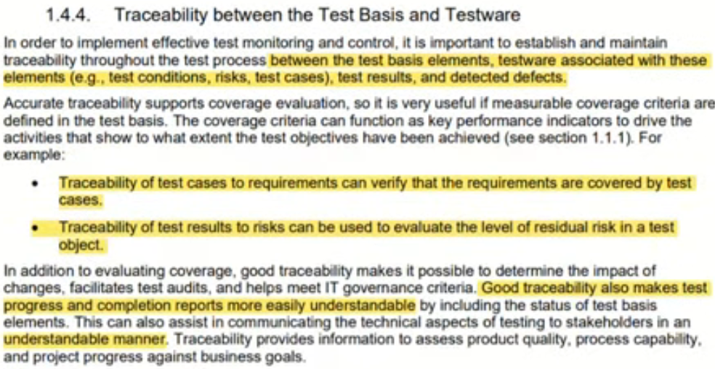

## 1.4.5-Roles in Testing

start at 1:23:23

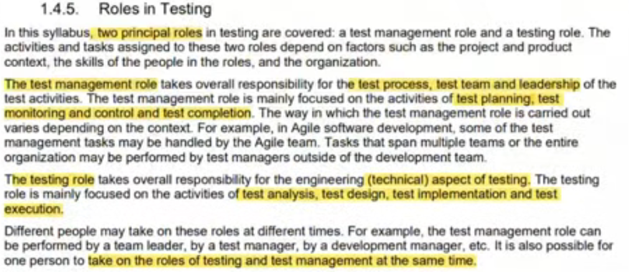

# 1.5-Essentials Skills and Good practices in Testing

start at 1:25:27

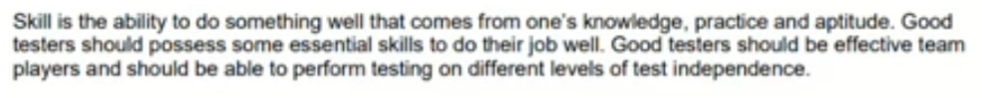

## 1.5.1-Generic Skills Required for Testing

start at 1:25:27

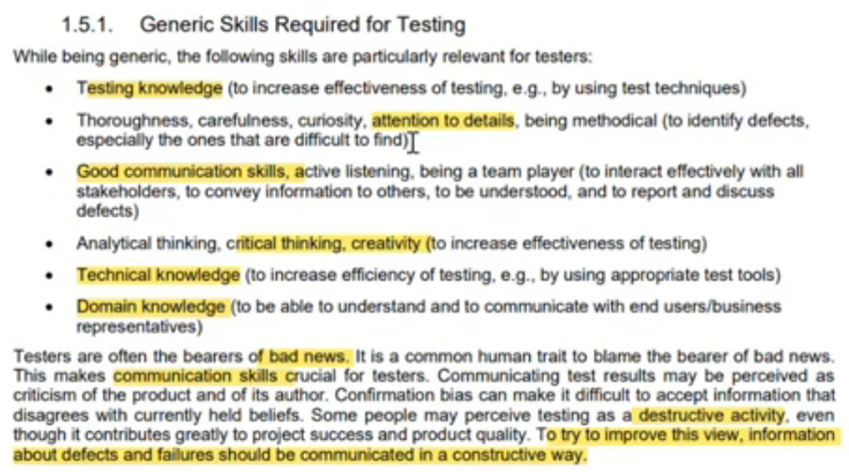

## 1.5.2-Whole Team Approach

start at 1:29:10

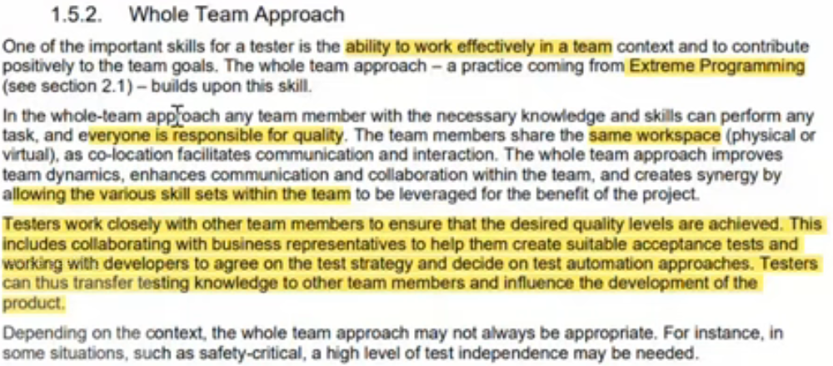

## 1.5.3-Independence of Testing

start at 1:31:17

